Project Deliverable 5: Infrastructure and Security
Name
Institution
Due Date

Justify and support the relationship between infrastructure and security as it relates to this data-collection and analysis company.
Data is the most important resource or valued asset for a company that collects and analyses data. It goes without saying that such a company will need a security plan that is very tight that cannot be easily compromised. Company value is determined by the analysis of their Big Data that has greatly grown over the years. Information Technology is undoubtedly very important to companies since it is through it that data is stored, analyzed, managed, and protected in a bid to work for the company business operations (Chen, 2012). The value of data in a company is dependent on the type, for instance a bank values most importantly its customers’ data which is attached an inherent value. Other data such the purchasing habit of customers for an organization have a derived value. This is a simple example to depict the variation that exists between different data but the bottom line remains that all these data is resourcefully important to corresponded companies.
As aforementioned, this data needs to be secured and the level of security is dependent on factors like IT infrastructure at the hands of the company. The IT infrastructure and security of the company are related. Among the key tenets of cybersecurity is confidentiality; the transmission of data through a network containing multiple users is kind of risking the data to unauthorized parties. Infrastructure entails access controls and a company having weak access controls is a huge problem that opens up company servers to unauthorized access. The second tenet of cybersecurity is integrity. The nodes of a network needs to be properly set for security reasons. This is, once again a factor of security that is related to a company’s infrastructure. It is possible for data being transmitted between network nodes to be compromised deliberately or unwillingly. This means that the data that the system will receive is malicious and this can lead to very negative effects to the company. More worse is the case of a data breach. Another tenet of security that establishes the relationship of infrastructure and security is the denial of service. It is evident that the network infrastructure of a company will depend on the consistent functioning of all network links that are connecting the network’s component codes. In case of any network disconnection or may be a slowed process, a system will not be able to make available the processes of data collection and analysis (Chen, 2012). System will also get compromised if the company’s infrastructure develops issues. Network tools such as routers, DNS servers, and modems among many other can be compromised in some situations hence leading to system’s unauthorized access.
Present the rationale for the logical and physical topographical layout of the planned network
The current network before upgrading is direct just like networks of small businesses. The elements that comprise both the logical and physical topographical layout of the planned network include database, mail server, and firewalls just to mention a few. These elements form the basis of data collection in a so specialized company (Biswajeet & Saied, 2010).
In the planned network, the company is said to be moving from first floor up to three floors. For the sake of simplicity, the layout will be set to remain the same as the current is. This is to mean that on each floor the layouts remain the same – physical and logical. It is only at the hub where connection is entirely wired, gathered and tied form one point. A router with high-loading capability is needful for the Wi-Fi needs. The server is then set to be shifted to the third floor in such a way that it will not be accessible to unauthorized party.
Design a logical and physical topographical layout of the current and planned network through the use of graphical tools in Microsoft Word or Visio, or an open source alternative such as Dia. Note: The graphically depicted solution is not included in the required page length.
Physical topographical layout of the current Network
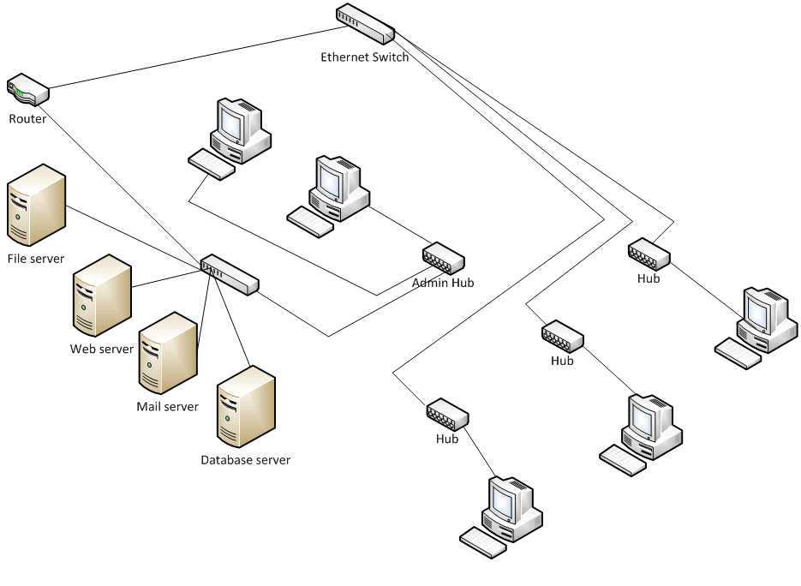
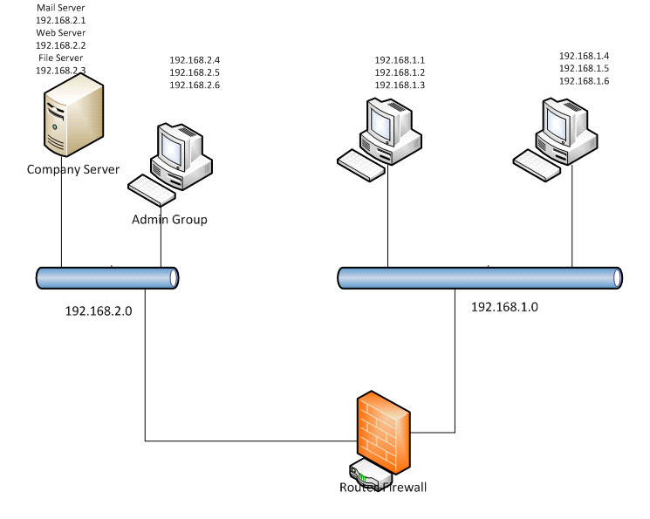
Logical
Physical topographical layout of the planned Network
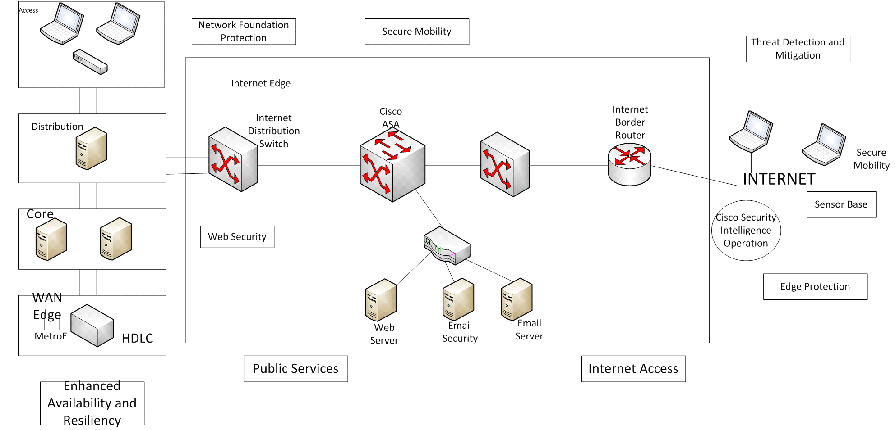

Illustrate the possible placement of servers including access paths to the Internet, intrusion detection systems (IDS), and firewalls. Note: Facility limitations, workstations, databases, printers, routers, switches, bridges, and access points should be considered in the illustration.
Network foundation protection; clearly shown in the illustration, regulation and management plane protection and device hardening are emphasized in this infrastructure that way improving availability tenet and resilience (Zhao et al., 2015).
Availability and resiliency enhanced; in the exhibit, a hardened device is set up to ensure that the company has optimal service availability while at the same time removing any case of an interface-associated or system redundancy.
Secure mobility; this is for the VPN protection which is a priority for mobile users. This is meant to conduct performance that is consistent and persistent in enhancement of policy not linked to location of staffs. It is a feature that uses web security and virus defense systems.
DMZ Public Services; this bit exhibits the placement of devices with the purpose of ensuring server protection at the end point, firewall inspection, intruder protection, application deep-packet inspection and DDoS protection (Zhao et al., 2015).
Internally, tools are configured as depicted in the illustration above. This is meant to ensure that there is email-web security, global correlation, granular access control, and state full firewall prevention.
Edge protection; a feature that ensures that traffic filtering, firewall integration, routing security, and IP address spoofing protection which discards anomalous traffic flows, block non-authentic traffic, and prevent unauthorized access. Threat detection and management; this prevents the intrusion of strangers and infrastructure telemetry dependent with the aim of identifying to mitigate threat.
Create and describe a comprehensive security policy for this data-collection and analysis company that will:
Data classification
As a user, having an access to a company’s system, the user can manipulate the classification of data. A user can change data classification given that there is enough and justifiable reasons of doing the same. To create new data, classification should assume “company only” data up to the point when the one will make modifications. Users are held responsible for change classification they make. Existing company data is classified as:
Company’s business information (memos, financial documents, planning documents etc.) should be classified as "Company Only";
Company’s customer data (contact details, contracts, billing information etc.) should be classified as "Company Only";
Network management data (IP addresses, passwords, configuration files, etc.) should be classified as "Confidential";
Human resources information (employment contracts, salary information, etc.) should be classified "Confidential";
Published information (pamphlets, performance reports, marketing material, etc.) should be classified "Shared";
E-mail between Company’s employees should be classified "Company only"; and,
E-mail between Company’s employees and non-Company employees should be regarded as "Unclassified".
Classifications: Roles and Responsibilities
- Responsibility of the user to:
Understand one’s own clearance level and to understand what are the rights and limitations associated with that clearance
Make sure that all the data one’s going to work on is correctly classified;
One is familiar with the restrictions associated with the data one’s working on and
Ensure all the data one works with is protected properly.
- Responsibility of all system owners and system administrators to:
Determine the security level for all users.
Proper verification of the equipment user is going to work with.
Installation of the equipment.
- Responsibility of each divisional manager is:
Getting approval on clearance for employees.
Clarifying the classification of data on systems.
Clarifying the classification of equipment.
Understanding and implementing the policy.
Responsibility of the Security Officer to:
Approving all classifications
Maintaining a list of all classifications
Approving the final layout of the company’s network.
Controlling and managing all trusted points
Compliance
Any unauthorized user accessing data, device, equipment or a location with insufficient privileges can face disciplinary action. Any user who is allowed to access a system that he/she controls on behalf of someone else with insufficient clearance can face disciplinary action. Any person who is trying to connect to an equipment for which one is not classified to access the network with an inappropriate part of the network can face disciplinary action, any person who is transmitting data over the network without specific privileges can face disciplinary action.

References
Biswajeet, P., & Saied, P. (2010). Comparison between prediction capabilities of neural network and fuzzy logic techniques for L and slide susceptibility mapping. Disaster Advances, 3(3), 26-34.
Chen, H., Chiang, R. H., & Storey, V. C. (2012). Business intelligence and analytics: From big data to big impact. MIS quarterly, 36(4).
Zhao, L., Sun, W., Shi, Y., & Liu, J. (2018). Optimal placement of cloudlets for access delay minimization in sdn-based internet of things networks. IEEE Internet of Things Journal, 5(2), 1334-1344.

